**CIS-350  
Infrastructure Technologies**

**Lab 2 Report**

**Student Name**: **___Trisia Baltazar_______________________________________________**

1. Insert *Lab2_Tree* file from p. 8 of the Lab 2 instructions into the space provided or use the *Alt-PrtScr* keys to capture the screen output (window) from command *TYPE Lab2_Tree* on p. 8 and paste that window here.

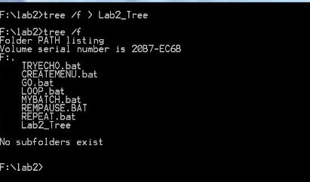

1. Assume that the system prompt displays "C:\>", i.e., your current directory and current drive are the root directory and C drive, respectively. Write a batch file below that will include commands to:
2. prevent all commands from displaying on the screen
3. display the following message "A simple batch file"
4. display the directory hierarchy of the C disk
5. display the directory hierarchy of the C disk with all files
6. create sub directory named *CLASSES* in the root directory
7. erase subdirectory *BOOK* from the root directory
8. copy file *Go.bat* to directory *CLASSES*
9. pause the screen
10. display the directory and pipe it through the *MORE* command
11. sort data in the ascending order coming from file *Letter3* and route the output to file *Letter3_Sorted*

The batch file, commands (a) through (j):

**ECHO OFF**

**REM A simple batch file**

**TREE**

**TREE /F**

**MD CLASSES**

**RD BOOK**

**COPY Go.bat \CLASSES**

**PAUSE**

**DIR | MORE**

**SORT <LETTER 3> Letter3_Sorted**

1. Describe step by step what a file named MYBATCH does.

**ECHO OFF**

**REM STARTING BATCH FILE**

**TREE /F**

**PAUSE**

**DIR**

**PAUSE**

**MD JOE MARY STACY**

**TREE /F**

**PAUSE**

**COPY *.BAT E:\LAB2\STACY**

**TREE /F**

**PAUSE**

**CD STACY**

**ERASE *.BAT**

**PAUSE**

**CD ..**

**TREE /F**

**PAUSE**

**RD JOE MARY STACY**

**TREE /F**

**PAUSE**

**REM CLOSING BATCH FILE**